3/15/2020

Vigneswaramoorthy Nagarajan

Hybris Certified Developer

Setup guide for recently viewed items

Table of Contents

Aim of this extension: 1

Scope of this extension: 1

Prerequisite: 1

Architecture: 2

Design Model: 2

How to setup: 3

# Aim of this extension:

Recently viewed addon will helps to store and retrieve the recent view products and category through its productID and categoryID.

Storage is based on the session strategy and it’s a configurable one through the properties.

# Scope of this extension:

It was targeted for B2C storefront / website.

Hybris version greater than 6.0.

# Prerequisite:

1. Hybris suite – 6.0 or greater
2. Required extensions – addonsupport, acceleratorstorefrontcommons, recentvieweditemsservices and recentvieweditemsaddon

# Architecture:

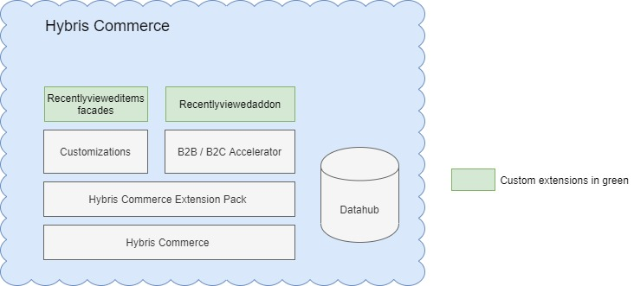

# Design Model:

1. Extension ‘recentlyviewedaddon’ is mainly communicate with storefront for UI view purpose.
2. Extension ‘recentlyvieweditemsfacades’ is mainly responsible to communicate with core extensions – recentvieweditemsaddon & recentvieweditemsservices
3. Current implementation was done based on session retrieval strategy.

# How to setup:

Step1: Download / clone the extension from git repo

Step2: Put this extension ‘*recentlyviewedaddon*’ in storefront extension’s exetnsioninfo.xml

Step3: Install the addon.

Step4: Configure the product count to store in session strategy through the parameter from - recentviewed.maxRecentViewedItems.count inside recentlyvieweditemsfacades\project.properties

Step5: Do ant clean all.

Step6: Start the Hybris server.